System Design Overview

**255,97,80**

**19,78,111**

* Application must be platform independent by hosting and accessing meaning we can host the application to any platform like Linux, Windows, Mac OS.
* User Access of the application also be independent to platform mean user can access the app or data from any source Android, OS, Linux, Windows, Browser etc.
* Must maintain single code base for all the platform (front and Back end).

**DB**

**APP**

**Front / Back**

**end**

**System Platform**

Linux, Windows, Mac OS

* SQLite
* PostgreSQL
* SQL Server
* Oracle
* Windows
* Linux
* Mac OS

**USERs**

**Desktop**

* **Windows**
* **Linux**
* **Mac Os**

**Mobile**

* **Android**
* **OS**

**Browser**

* **Chrome**
* **Firefox**
* **Edge**

Application

Overview of the Application architecture view

**Common**

**DB**

**Users**

**Exceptions**

**Notification**

**Chat**

**Files**

**Modules**

**Accounts**

**Projects**

**Inventory**

**CRM**

**Tasks**

**Contacts**

**Existing ( Third Party / Free )**

* **Import / Export**
* **OCR**
* **AI**

Core View

**CORE**

**Accounts**

**Inventory**

**Tasks**

**Contacts**

**CRM**

**Projects**

Database

Design Doc

Quick Code Test

This section contains the codes for quick understanding the concepts and problems

Interfaces implements

Below is the implementation code of interface to understand the concepts

|  |  |  |
| --- | --- | --- |
| **public interface IService**  **{**  **void Serve();**  **}** | **public class** **Service1** : **IService**  {  **public void** Serve()  {  **Console.WriteLine(**"Service1  Called");  }  } | **public class Service2** :  **IService** {  **public void** Serve()  {  **Console.WriteLine**("Service2  Called" );  }  } |

|  |  |
| --- | --- |
|  |  |

EF core

S

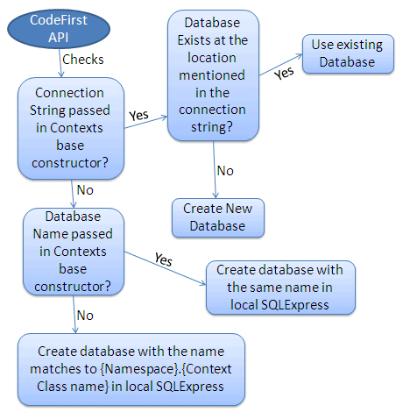

Code

Some Code

Code

Some Code

Code

Some Code

Code

Some Code

Code

Some Code

Code

Some Code

# Hedding

sadfsadf